1.

*// define x*

x0= 0;

xinc=0.001;

xf=1;

x=x0:xinc:xf;

*//Calculate analytic Solution*

y=sqrt(x.^2+2*x+0.01);

*//Plot analytic Solution*

subplot(2,1,1),

plot(x,y),

xgrid

ylabel ('y(x)','fontsize',2)

title('Analytic Solution ','fontsize',2)

*// Define differential equation*

deff('yprim=f(x,y)','yprim=(x+1)/y');

*// Solve Differential Equation*

y0=0.1;

ydiff=ode(y0,x0,x,f);

*// plot numeric solution*

subplot(2,1,2),

plot(x,ydiff,'r'),

xgrid

title('Numeric solution ','fontsize',2)

ylabel ('y(x)','fontsize',2)

xlabel('x','fontsize',2)

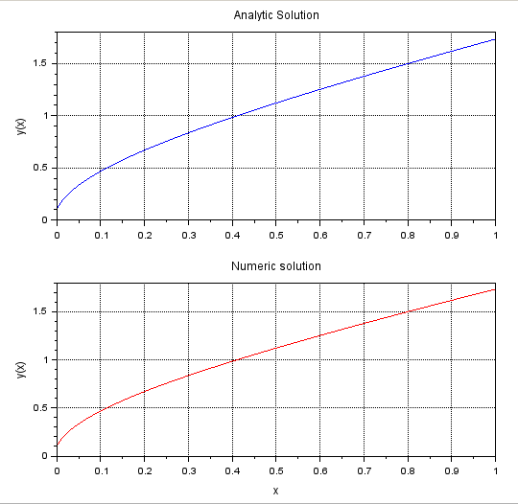

2.

function **ydot**=f(**t**, **y**)

**ydot**=**y**^2-**y**\*sin(**t**)+cos(**t**)

endfunction

y0=0;

t0=0;

t=0:0.1:%pi;

y=ode(y0,t0,t,f);

plot(t,y);

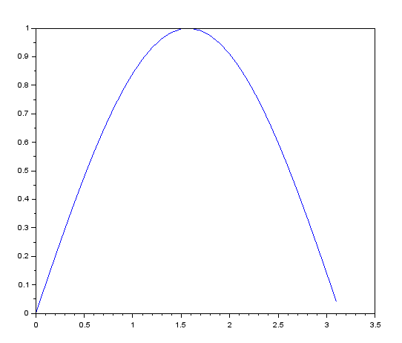

3.

function **xdot**=linear(**t**, **x**, **A**, **u**, **B**, **omega**)

**xdot**=**A**\***x**+**B**\***u**(**t**,**omega**)

endfunction

function **ut**=u(**t**, **omega**)

**ut**=sin(**omega**\***t**)

endfunction

A=[1 1;0 2];

B=[1;1];

omega=5;

y0=[1;0];

t0=0;

t= [0.1,0.2,0.5,1];

ode(y0,t0,t,list(linear,A,u,B,omega));

plot(t,u);

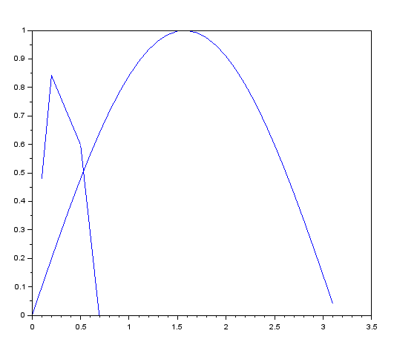

4

function **y**=u(**t**)

**y**=(sign(**t**)+1)/2

endfunction

L=0.001

R=10

C=0.000001

function **zdot**=f(**t**, **y**)

**zdot**=[**y**(2); (u(**t**)-**y**(1)-L\***y**(2)/R)/(L*C)];

endfunction

y0=[0;0];

t0=0;

t=0:0.00001:0.001;

out=ode(y0,t0,t,f);

clf();

subplot(211)

plot(t,out(1,:),"r.--");

subplot(212)

plot(t,out(2,:),"b-..");

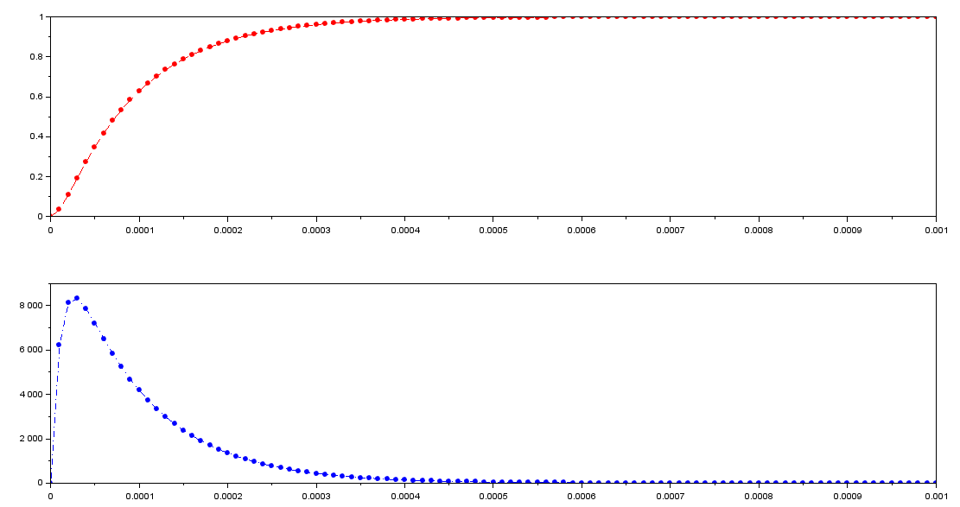

5

clc;

clear;

function **dx**=f(**t**, **x**)

**dx**(1)=**x**(2);

**dx**(2)=1/(**t**+1)+sin(**t**)*sqrt(**t**);

endfunction

t=0:0.01:5*%pi;

t0=min(t);

y0=[0;-2];

y=ode(y0,t0,t,f);

plot(t,y(1,:),'LineWidth',2)

plot(t,y(2,:),'r','LineWidth',2)

xgrid();

xlabel('$t\quad[s]$','FontSize',3);

ylabel('$f(t,x)$','FontSize',3);

title(['Integration of' '$\frac{d^2 x}{d1^2}=\frac{1}{t+1} + sint(t)\sqrt{t}$'],'FontSize',3)

legend(['$\Large{x}$' '$\Large{dx/dt}$'],2)

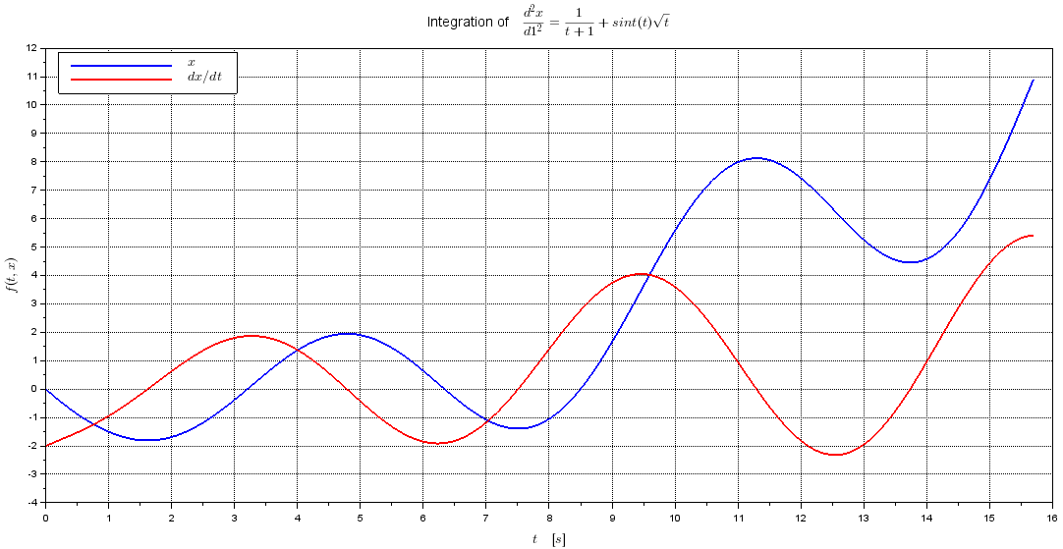

6

clc;

clear;

funcprot(0)

clf;

function **dx**=f(**x**, **y**)

**dx**=exp(-**x**);

endfunction

y0=0;

x0=0;

x=[0:0.5:10];

sol=ode(y0,x0,x,f);

plot2d(x,sol,5)

xlabel('x');

ylabel('y(x)');

xtitle('y(x) vs. x');

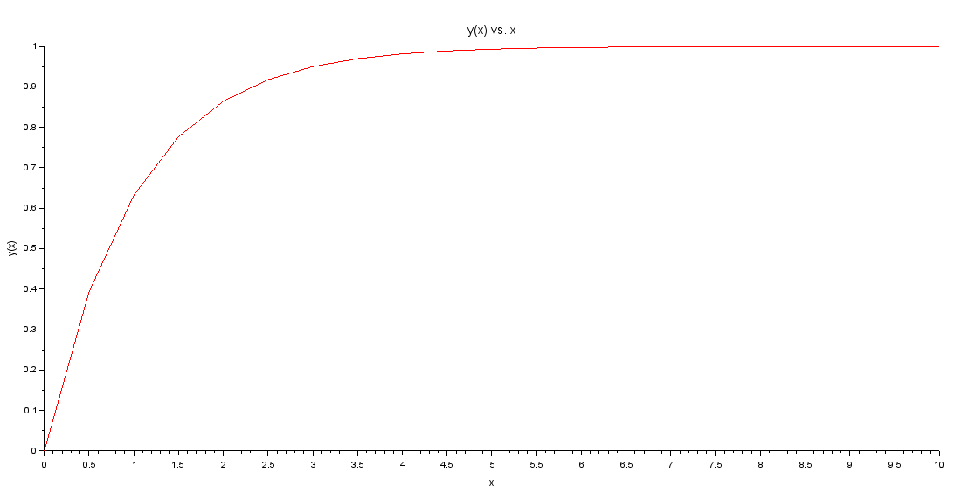

7

clc;

clear;

funcprot(0)

clf;

function **dx**=f(**x**, **y**)

**dx**=**x**^2-exp(-**x**)\***y**;

endfunction

y0=0;

x0=0;

x=[0:0.5:10];

sol=ode(y0,x0,x,f);

plot2d(x,sol,5)

xlabel('x');

ylabel('y(x)');

xtitle('y(x) vs. x');

